|  |  |
| --- | --- |
| **Student**: | Michael Escue |
| **Assignment**: | Assignment #3 |
| **Class**: | ECE 373 |
| **Instructors**: | Peter (PJ) Waskiewicz,  Charles Stoll |
| **Term**: | Spring 2019 |

**Target**: Advantech AIMB-212

**Question 1:**

1. *What is the audio device?*

AC-97 audio interface.

1. *What device is the GPIO connected to?*

The 8-bit GPIO is connected to a Super IO Winbond W83627DHG through a bi-directional connection.

1. *How many network (LAN) devices are on the motherboard and what are they?*

The board has two Gigabit Ethernet LANs, LAN 1 (Intel 82567V) and LAN 2 (Intel 82583V).

1. *How many total serial ports does the box support, inside and out?*

8 serial ports. Serial ATA 0, Serial ATA 1, and Serial Ports COM1 – COM6. COM2 is RS-232/422/485 and the other 5 COM ports are RS-232 only.

**Question 2:**

* *Find the datasheet for the LAN device connected through PCIe (not through the integrated chip’s LCI). Read the Pin interface chapter on how to physically connect to the chip. Find the memory mapped register and bit patterns to perform “things”.*

The device is a Gigabyte LAN2: Intel 82583V

1. *What pins control the LEDs?*

LED0 Lead # 31 Output

LED1 Lead # 30 Output

LED2 Lead # 33 Output

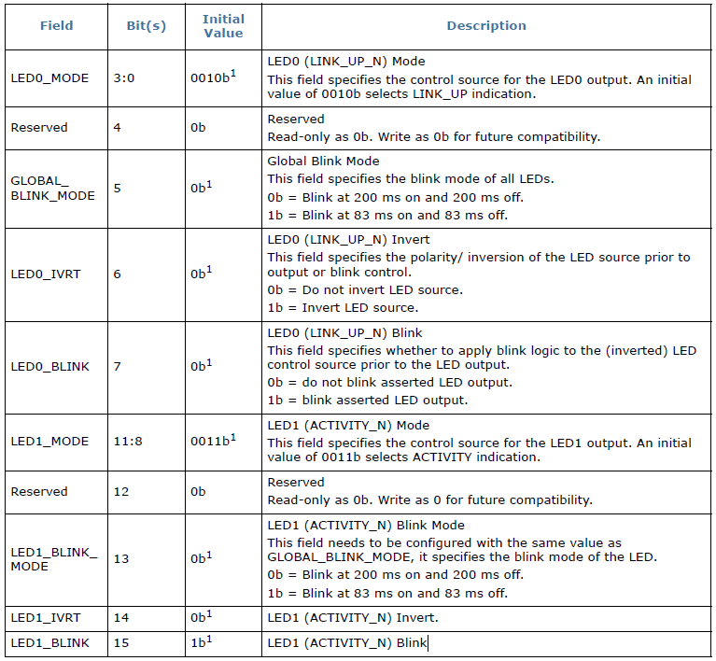

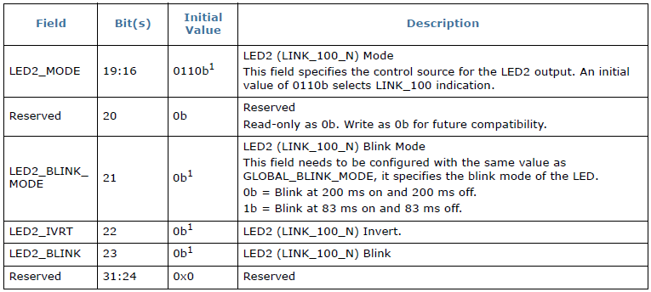

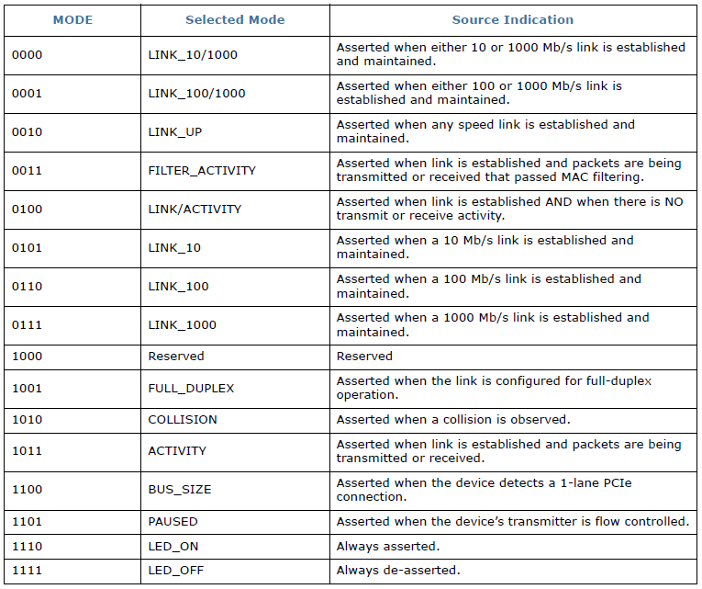

1. *What address offset is the Device Control Register?*

**CTRL** Register offset: 0x00000 / 0x00004

1. What bit in the Device Control Register will force a reset of the network chip?

Bit 26 when set initiates a device reset.

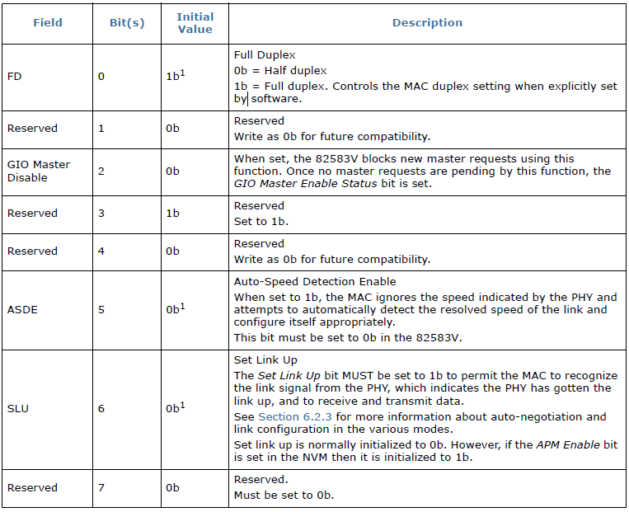

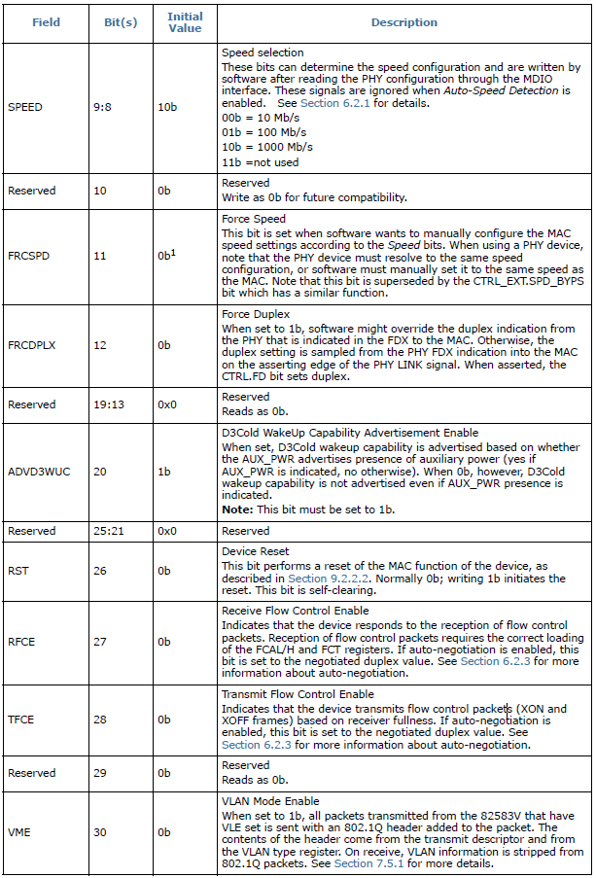

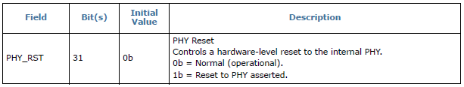

**Question 3:**

1. *What register (name and address) controls the LEDs?*

The configuration for LED outputs is specified via the **LEDCTL** register.

**LEDCTL** Register offset: 0x00E00

Non-Volatile Memory (NVM) Map Address Range: 0x00-0x3F

LEDCTL0, LEDCTL2 NVM offset: 0x1F

1. *What bit pattern should you use to turn off LED1?*

AND 1111_1111_0000_1111_1111_1111­_1111_1111